SE401 – Assignment 6.1

Solve the following questions and submit your answers to LMS.

Homework Tips Checklist for Parents

# Questions

In this assignment, your task is to develop a set of test cases using the black-box testing techniques to adequately test the functions described below. To make the test cases more succinct and more manageable, you should group similar or related test cases together. For each test case (or group of test cases when appropriate), indicate the intent or purpose of the test case, provide specific values for input whenever possible, and describe the expected output based on the information provided in the description. You may make reasonable assumptions that are consistent with the description, but clearly document your assumptions. Hint: It is reasonable to make assumptions based on common knowledge of how things are and how things should work. These are often implied in software specifications and not explicitly written down.

1. The following is a partial screen shot of an intranet web application for the faculty of the CCIS to retrieve academic records of past and current students of CCIS.



Assuming that the user has been authenticated, he/she can enter either of the following in the search box:

1. The ID of a student, which consists of 7 or 8 digits, or
2. The last name or full name of a student.

The result of the search operation can be one of the following:

1. If an unique match is found, the record of the matching student shall be displayed
2. If multiple matches are found, a list of full names of all matching students, in ascending alphabetical order of their last names then first name, shall be displayed for selection.
3. If no match is found, an appropriate message shall be displayed to indicate so.
4. If the search operation cannot be successfully completed for any reason, an appropriate message shall be displayed.

Write a set of test cases using the black-box testing techniques to adequately test this search function.

2 The following is a partial screen shot of an intranet web application for an instructor to submit an exam for a course he/she is teaching during the current quarter. The instructor has been authenticated at this point and one of the courses currently taught by the instructor has been selected.

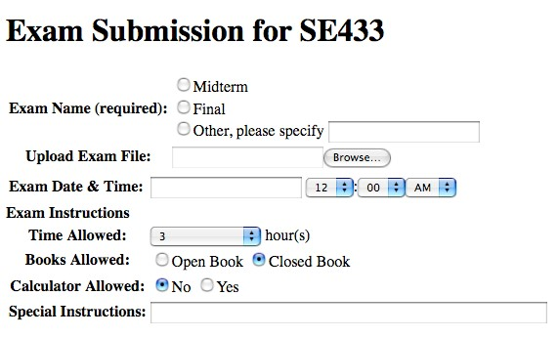

The input fields of this function are briefly explained below:

* The *Exam Name* is a required field.
* The *Upload Exam File* field is optional. The name of a local file to be uploaded can be entered directly in the textbox. The *Browse* button will bring up a standard file dialog to choose a local file.
* The *Exam Date & Time* fields are all required. The date is entered in the textbox and the time is specified using the dropdown menus.
* The *Time Allowed* field is required. The dropdown menu offers the options as shown in the screen shot below:

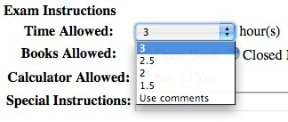

* The *Books Allowed* and *Calculator Allowed* fields are both required with default values provided as shown in the screen shot.
* The *Special Instructions* field is optional. Text can be entered in the textbox.

Your goal is to adequately test this function using the black-box testing techniques.

1. For each of the input field of this function,
   1. Identify the valid and invalid equivalence classes.
   2. Identify a set of valid and invalid input values that should be tested, including boundary values and special values.
2. Based on the description, identify combinations of the fields that should be tested. For each of these combinations of the input fields, identify a set of valid and invalid combined input values (i.e., input values for all the fields in the combination) that should be tested.

(Note: You need to enumerate specific input values not just general descriptions. You must indicate for each input value whether it is valid or invalid.)